AI-BASED FINANCIAL IDENTIFICATION BASED ON DEMOGRAPHY AND FINANCIAL FORECASTING
Block Diagrams (all)
Product: FinSight AI
Department of Computer Science and Engineering, TKR College of Engineering and Technology (Autonomous)
Batch C9 (CSE-C) · Academic year [ACADEMIC YEAR]
Table 1: Project team
S.No. | Student name | Roll number
1 | MOHD AHMED | 23K91A05F7
2 | MANNE UPENDER | 23K91A05E6
3 | PADALA RAJESH | 23K91A05H7
4 | MADAGOUNI HARSHAVARDHAN GOUD | 23K91A05D5

Project guide: B SRIKANTH
Chapter and section numbers quoted in the text (for example Section 6.6 or Chapter 8) refer to the full project report, 17.Final Document. Figures and tables in this document are numbered from 1.

1. INDEX OF DIAGRAMS
Every diagram is generated from the real design by scripts/make_diagrams.py (matplotlib, 150 dpi) and mirrors the code in app/routes.py, app/api.py, app/services/, app/utils/validation.py and scripts/.
Table 2: Diagrams in this document
No. | Diagram | Image file
1 | System architecture | docs/diagrams/01_system_architecture.png
2 | High-level workflow | docs/diagrams/02_high_level_workflow.png
3 | Data flow diagram, level 0 | docs/diagrams/03_dfd_level0.png
4 | Data flow diagram, level 1 | docs/diagrams/04_dfd_level1.png
5 | Data flow diagram, level 2 | docs/diagrams/05_dfd_level2.png
6 | UML class diagram | docs/diagrams/06_uml_class_diagram.png
7 | Sequence diagram | docs/diagrams/07_sequence_diagram.png
8 | Use-case diagram | docs/diagrams/08_use_case_diagram.png
9 | Entity-relationship (data model) diagram | docs/diagrams/09_er_diagram.png
10 | Flowchart of the core algorithm | docs/diagrams/10_core_algorithm_flowchart.png
11 | Offline training and evaluation pipeline | docs/diagrams/11_training_pipeline.png

2. DIAGRAMS

System architecture
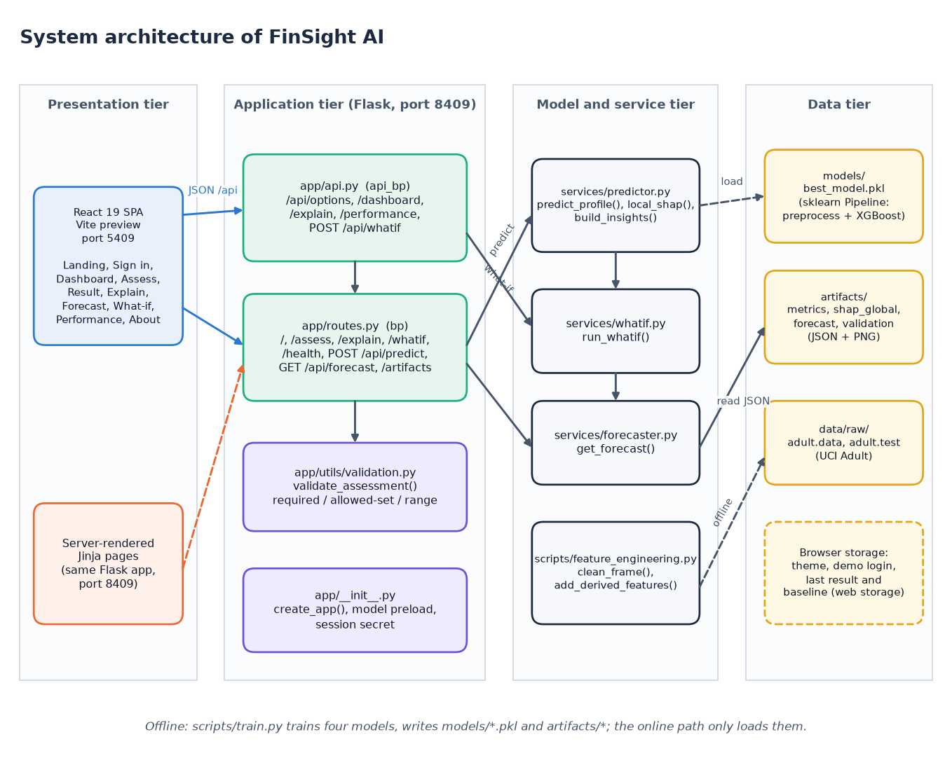
Figure 1: System architecture of FinSight AI
The system has four tiers. In the presentation tier the React single-page application (served by Vite on port 5409) and the server-rendered Jinja pages of the original Flask project are the two ways a user reaches the system. The application tier is the Flask service on port 8409: app/api.py holds the JSON routes written for the React front end, app/routes.py holds the page routes plus /api/predict and /api/forecast, app/utils/validation.py checks every input and app/__init__.py builds the application and preloads the model. The model and service tier contains predictor.py (prediction, SHAP and insights), whatif.py, forecaster.py and the shared feature_engineering.py. The data tier is made of files: the persisted pipeline in models/, the JSON and PNG artifacts, the raw census files and browser storage.

High-level workflow
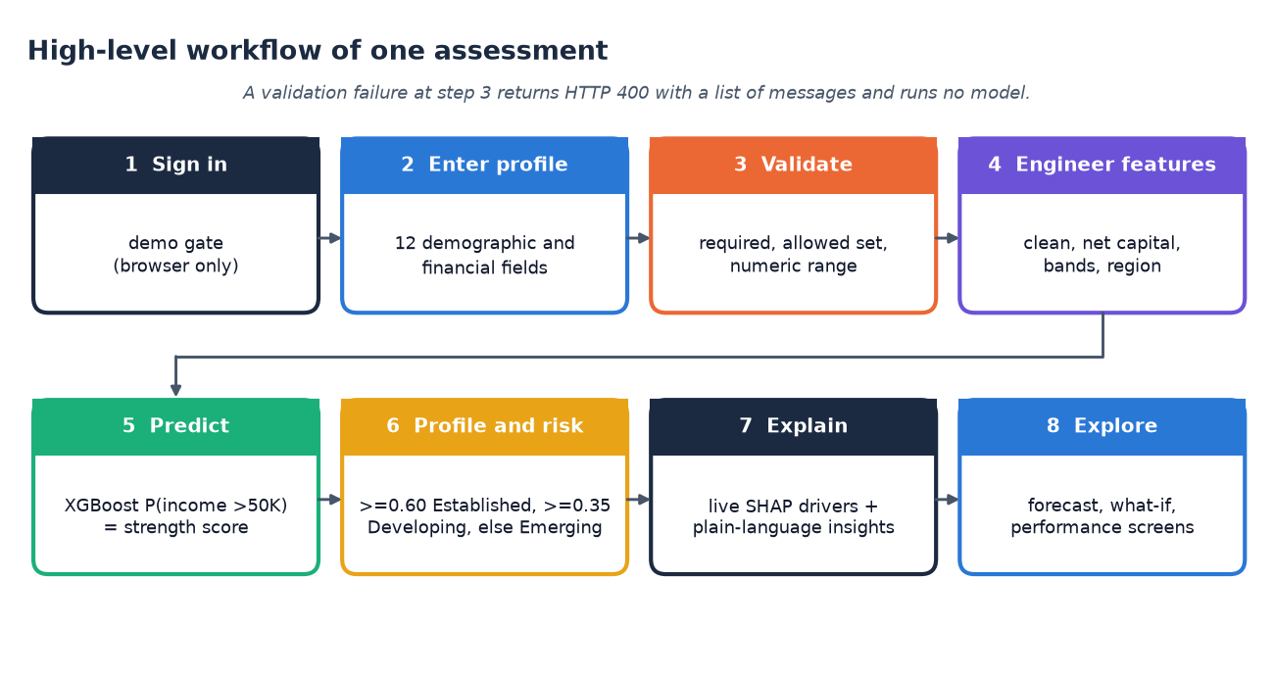
Figure 2: High-level workflow of one assessment, from sign-in to exploration
One assessment passes through eight steps. The user signs in through the demo gate and enters the twelve demographic and financial fields. The server validates that every field is present, belongs to its allowed set and lies in its numeric range; a failure ends the flow with HTTP 400 and a list of messages, and no model is run. Valid input is cleaned and extended with the derived features, and the saved XGBoost pipeline returns the probability of income above 50K, which is the financial-strength score. The probability is mapped to a profile and a risk band, and SHAP contributions plus rule-based insights explain it. The user can then open the forecast, the what-if comparison and the performance screens.

Data flow diagram, level 0
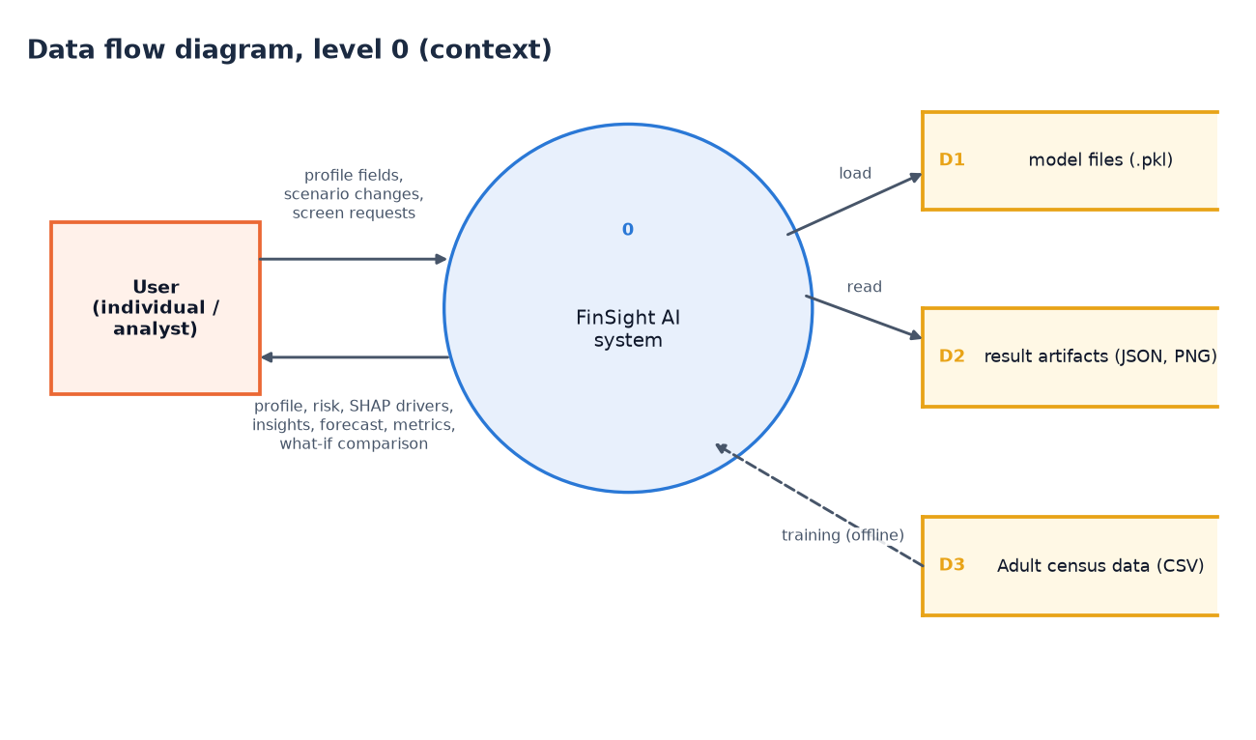
Figure 3: Data flow diagram, level 0 (context diagram)
The context diagram shows FinSight AI as one process with one external entity, the user. The user sends profile fields, scenario changes and requests for the other screens; the system returns the profile, risk band, SHAP drivers, insights, forecast, metrics and what-if comparison. Three data stores surround the process. D1 holds the trained model files, which are loaded and never modified while the application runs. D2 holds the result artifacts (metrics, SHAP importance, forecast and validation reports as JSON and PNG), which are read. D3 is the Adult census data; it is touched only by the offline training run, drawn as a dashed arrow, which is the only place where D1 and D2 are written.

Data flow diagram, level 1
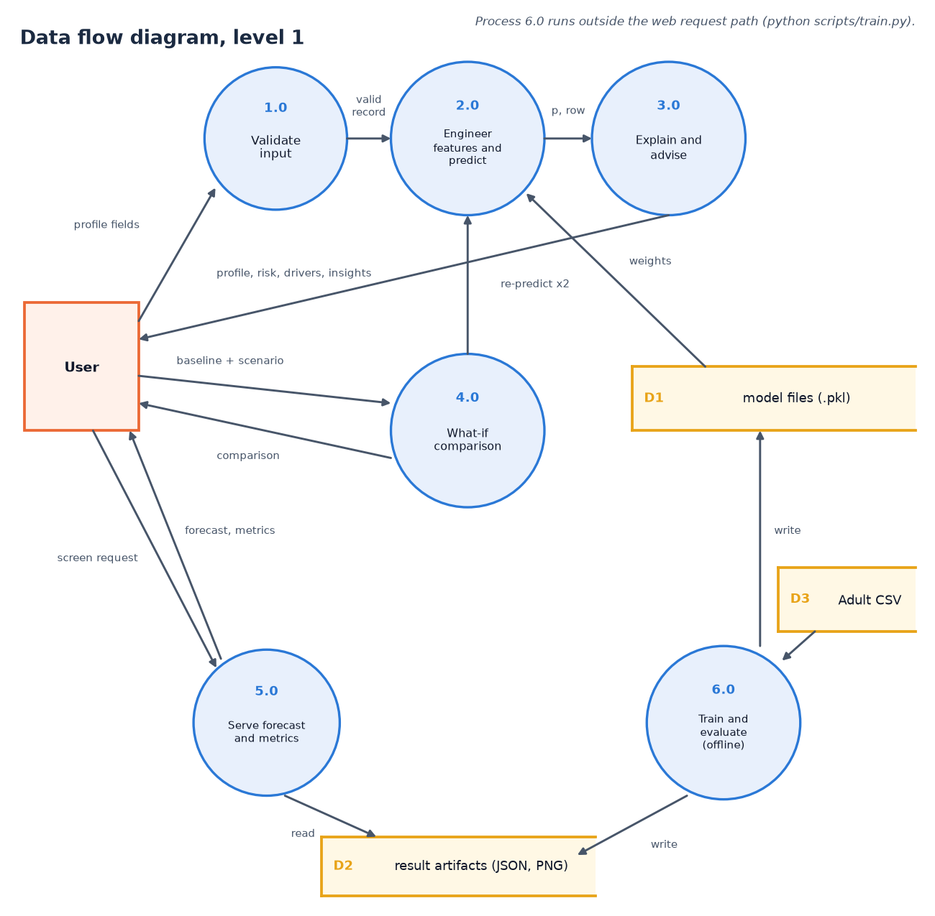
Figure 4: Data flow diagram, level 1
Level 1 splits the system into six processes. Validate input (1.0) turns the raw form values into a valid record or an error list. Engineer features and predict (2.0) builds the feature row and obtains the probability from the pipeline stored in D1. Explain and advise (3.0) computes SHAP contributions and plain-language insights and returns the profile, risk band, drivers and insights to the user. What-if comparison (4.0) receives a baseline and a scenario and calls process 2.0 twice. Serve forecast and metrics (5.0) answers screen requests by reading D2. Train and evaluate (6.0) runs offline: it reads the census data (D3) and writes the model files (D1) and the artifacts (D2).

Data flow diagram, level 2
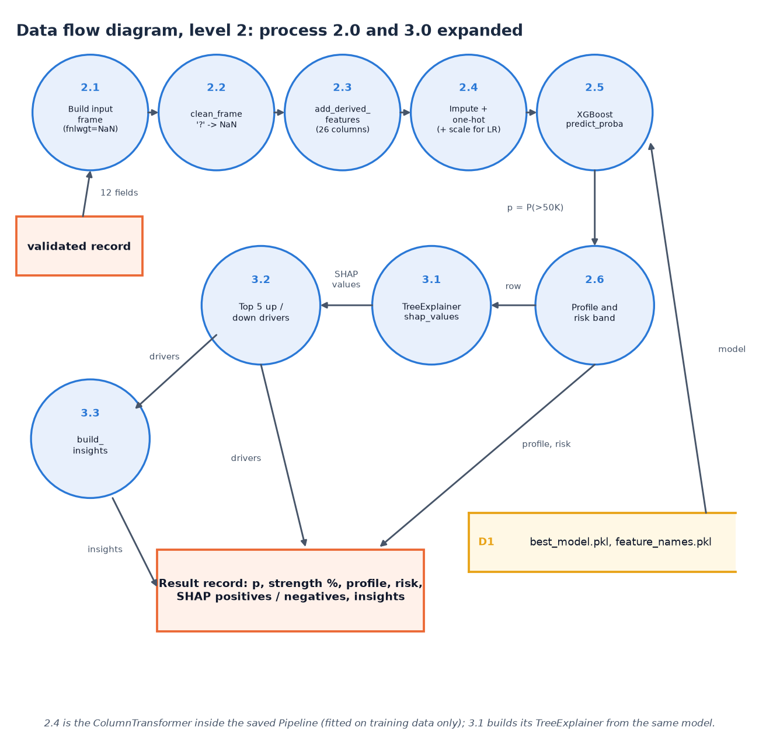
Figure 5: Data flow diagram, level 2: processes 2.0 and 3.0 expanded
Level 2 expands the prediction and explanation processes in the order the code executes them. The validated record becomes a one-row frame in which the census weight is left missing (2.1); clean_frame converts '?' markers to missing values (2.2); add_derived_features adds the net-capital, band, tier, region and stability columns, giving 26 columns (2.3); the preprocessing step of the saved pipeline imputes, one-hot encodes and, for logistic regression only, scales (2.4); XGBoost returns the probability (2.5). The probability becomes a profile and risk band (2.6). In parallel the same row goes to the TreeExplainer (3.1), the five strongest positive and negative contributions are selected (3.2) and the insight rules write the advice (3.3). All of it is assembled into one result record.

UML class diagram
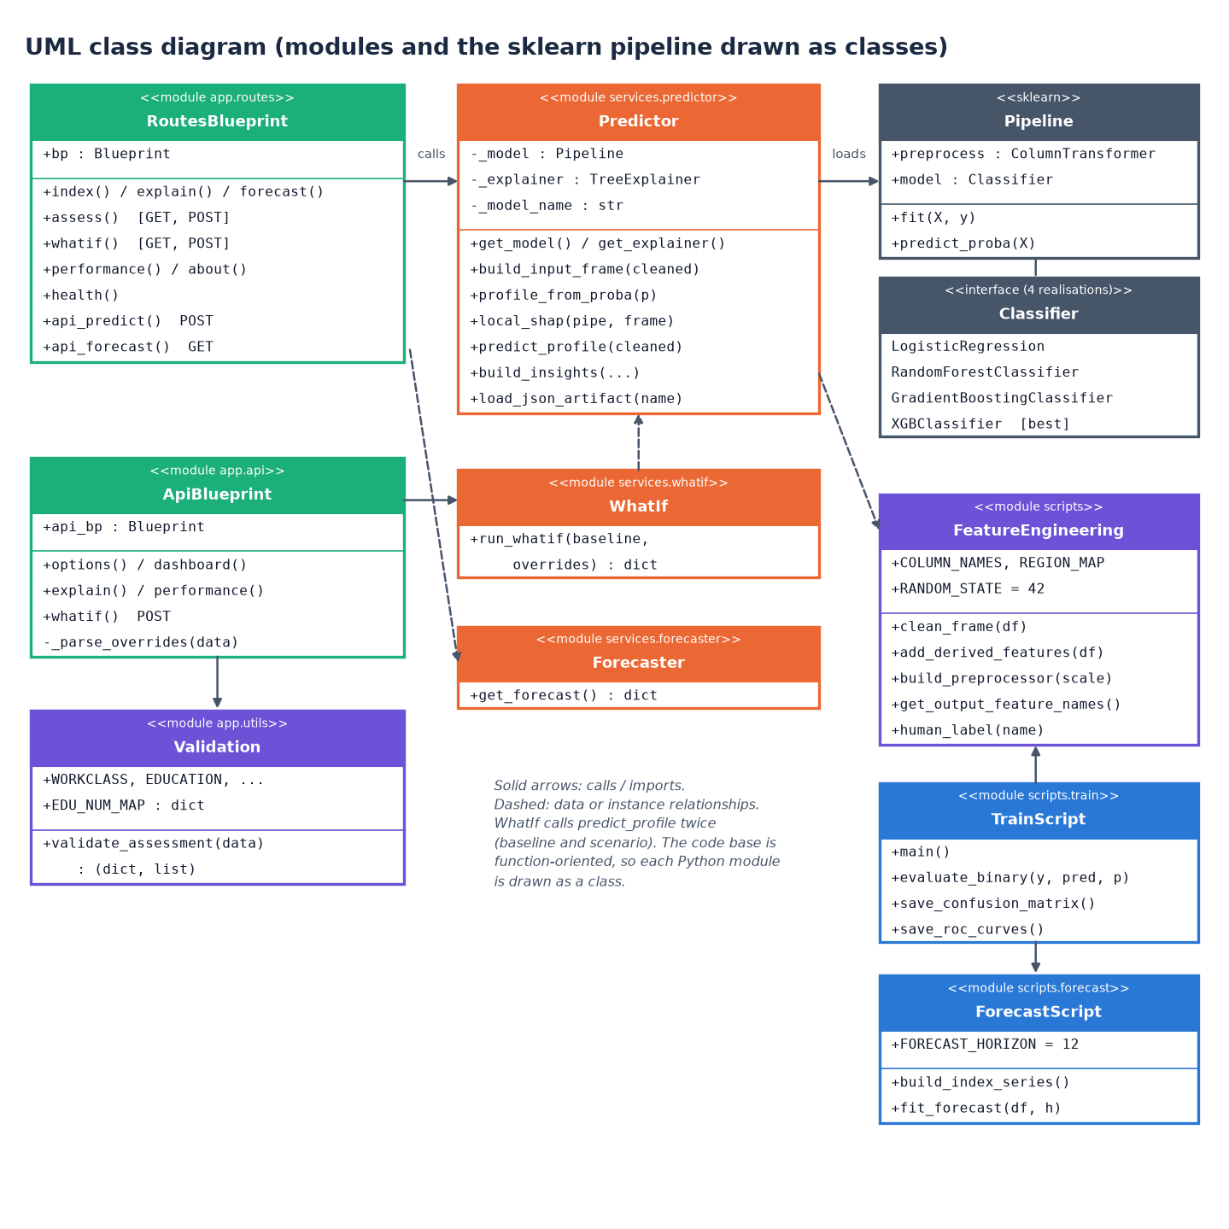
Figure 6: UML class diagram (modules drawn as classes)
The code base is function-oriented, so each Python module is drawn as a class stereotyped as a module, listing its constants and public functions. RoutesBlueprint and ApiBlueprint are the two Flask blueprints; both depend on Validation for input checking, and the routes call Predictor, which owns the cached model, the cached explainer and the prediction, SHAP and insight functions. WhatIf calls predict_profile twice, Forecaster reads the forecast artifact, and FeatureEngineering supplies cleaning, derived features and the preprocessor. A scikit-learn Pipeline combines the preprocessor with one of four classifier realisations, XGBoost being the selected one. TrainScript and ForecastScript are the offline modules.

Sequence diagram
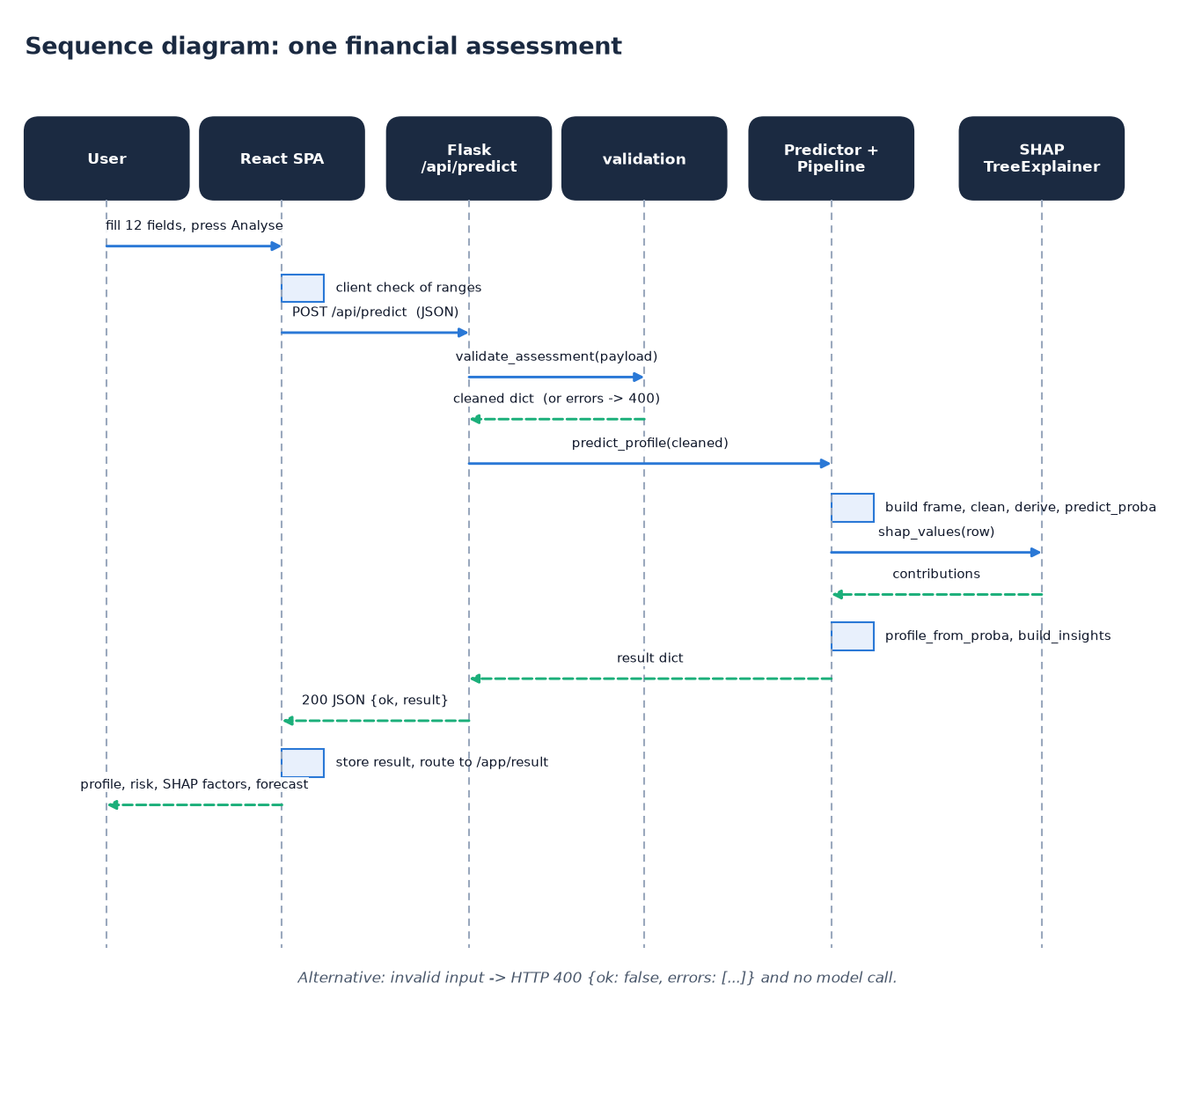
Figure 7: Sequence diagram: one financial assessment
The sequence follows one assessment. The user fills the twelve fields in the React page, which first checks the ranges in the browser and then posts the values as JSON to /api/predict. The route calls validate_assessment; on success it calls predict_profile, which builds the frame, derives the features and obtains the probability from the pipeline. It then asks the TreeExplainer for the SHAP values of that single row, maps the probability to a profile and band, and builds the insights. The result dictionary travels back as an HTTP 200 JSON body; the page stores it in the browser session and navigates to the result screen, which shows the profile, score bar, SHAP factors, insights and the forecast. Invalid input short-circuits with HTTP 400.

Use-case diagram
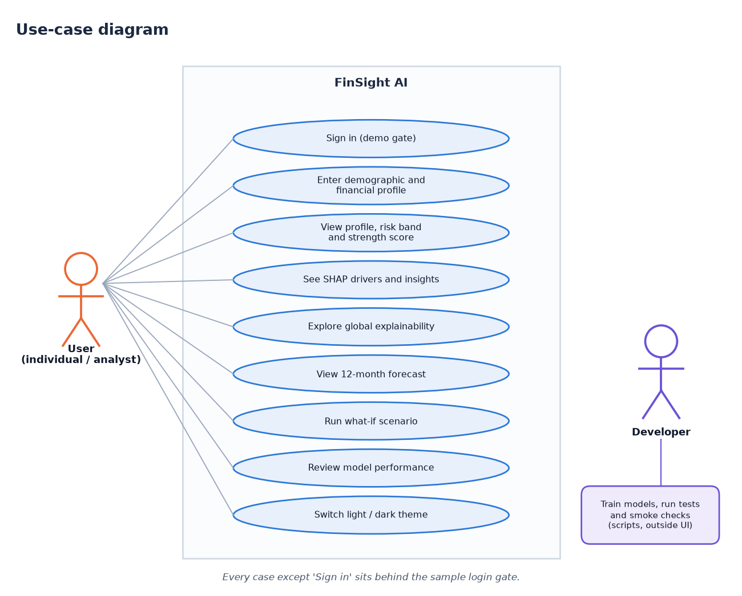
Figure 8: Use-case diagram
The user can sign in with the demo account, enter a demographic and financial profile, view the profile, risk band and strength score, read the SHAP drivers and insights, explore the global explainability charts, view the 12-month forecast, run a what-if scenario, review the model performance and switch between light and dark themes. Every case except signing in sits behind the sample login gate. The second actor, the developer, trains the models and runs the tests and smoke checks from the command line; those activities are outside the web interface and are drawn separately to show that the running application never retrains a model.

Entity-relationship (data model) diagram
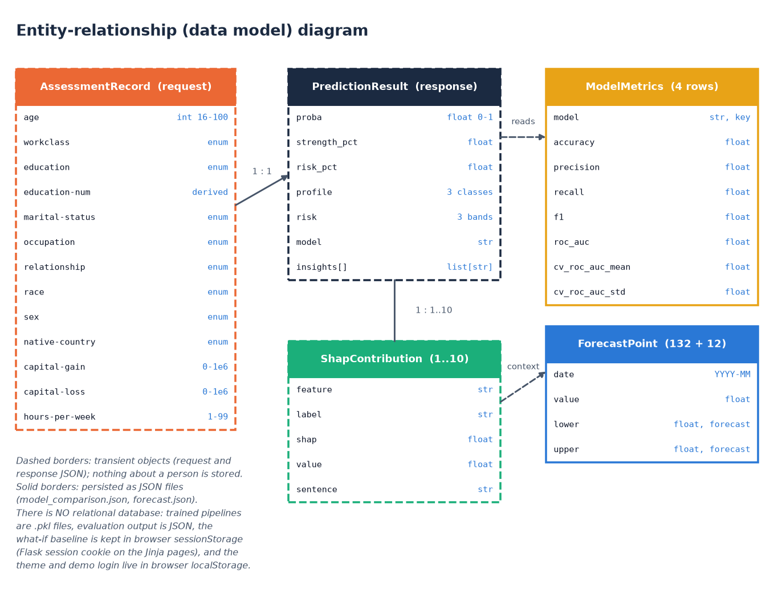
Figure 9: Entity-relationship (data model) diagram
FinSight AI has no relational database, so the diagram shows the data model instead of tables. Dashed boxes are transient objects that exist only inside one request: the assessment record (the twelve inputs, with education-num derived), the prediction result and the SHAP contributions, between one and ten per result. Solid boxes are persisted as JSON: the model-metrics rows (four models, with test and cross-validation scores) and the forecast points (132 history points and 12 forecast points). One request produces one result, which holds many SHAP items. Nothing about a person is written to disk; the what-if baseline lives only in browser or session storage.

Flowchart of the core algorithm
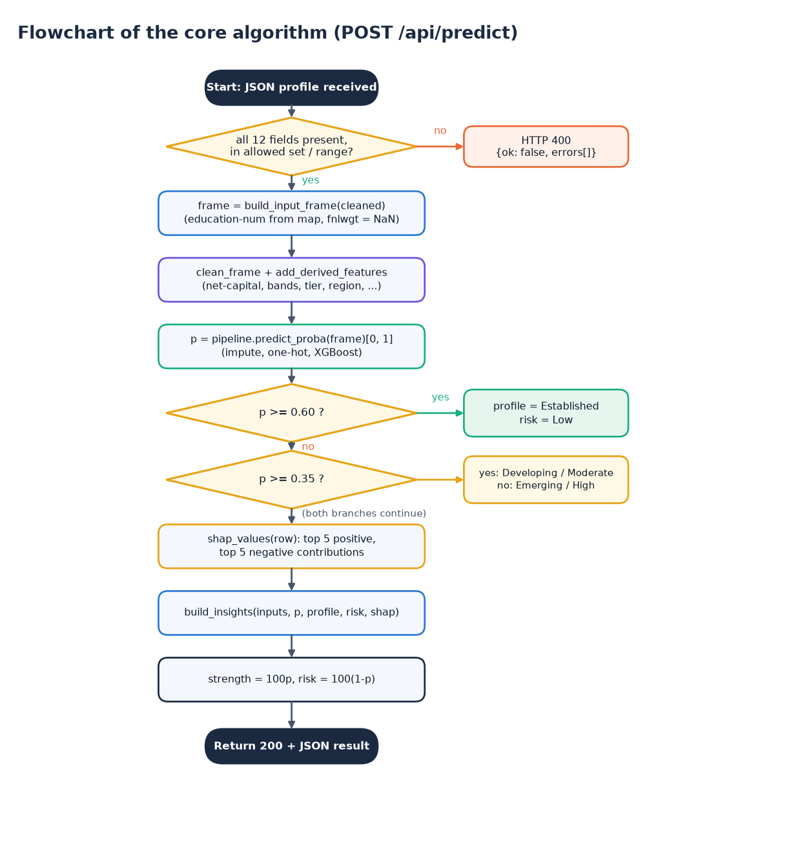
Figure 10: Flowchart of the core algorithm (POST /api/predict)
The flowchart gives the decision logic of the prediction endpoint. A JSON profile is received and validated; a missing, disallowed or out-of-range field returns HTTP 400 with the error list. Otherwise the input frame is built (education-num looked up from the education level, census weight left missing), the cleaning and feature-derivation functions run, and predict_proba returns the probability p of income above 50K. Two comparisons decide the label: p of at least 0.60 gives Established with Low risk, p of at least 0.35 gives Developing with Moderate risk, and anything lower gives Emerging with High risk. The SHAP contributions and insights are then computed, strength is set to 100p and risk to 100(1-p), and a 200 response is returned.

Offline training and evaluation pipeline
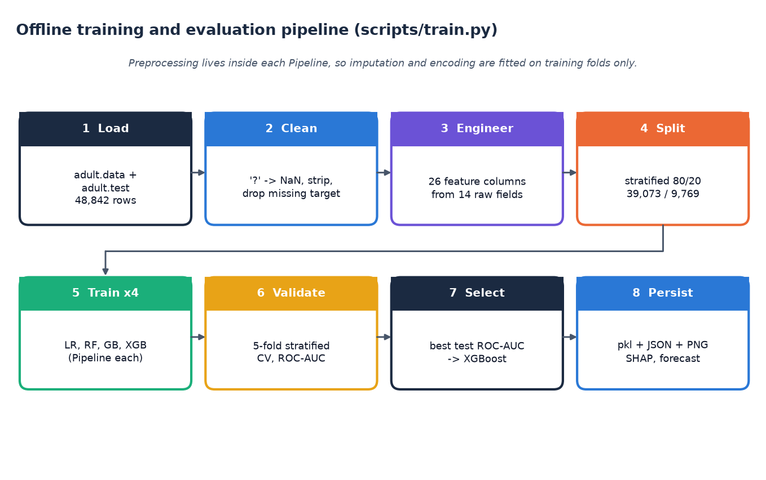
Figure 11: Offline training and evaluation pipeline (scripts/train.py)
Training is a separate offline script with eight steps. It loads adult.data and adult.test (48,842 rows), cleans them ('?' to missing, whitespace stripped, rows without a target dropped), engineers 26 feature columns from the 14 raw fields, and makes a stratified 80/20 split (39,073 training and 9,769 test rows). Each of four classifiers is wrapped in its own Pipeline together with its preprocessor, scored by 5-fold stratified cross-validation on the training split and then fitted and evaluated on the test split. The model with the highest test ROC-AUC is selected, and the pickles, JSON reports, charts, SHAP importance and forecast are persisted for the web application to load.

